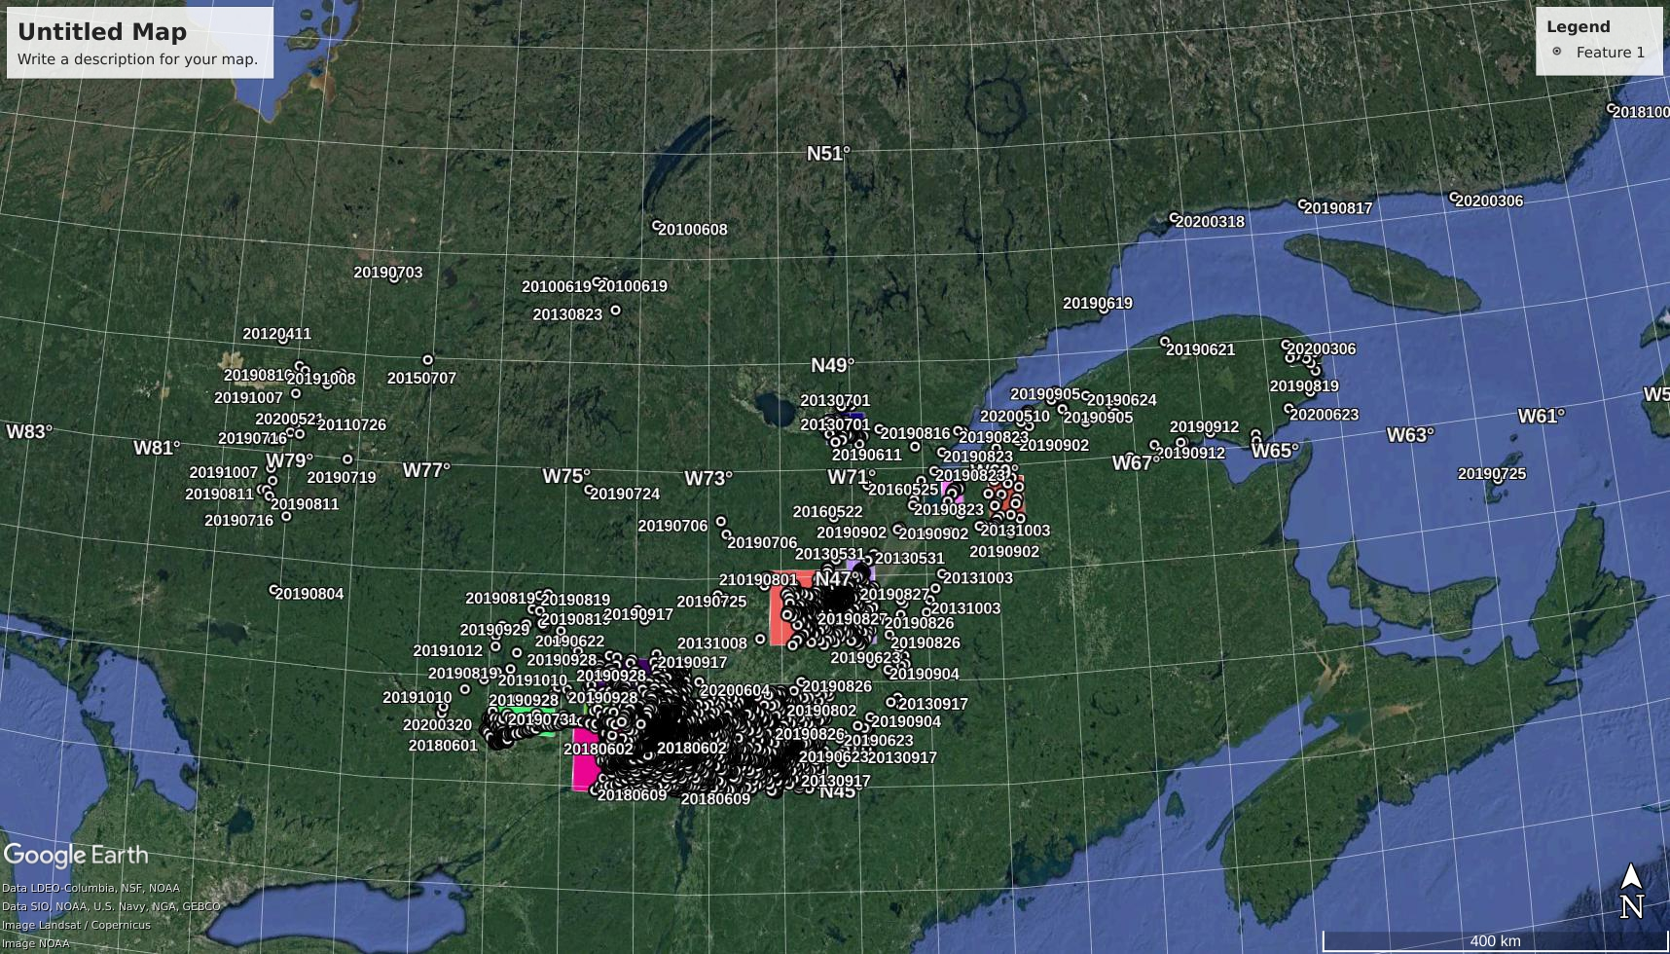

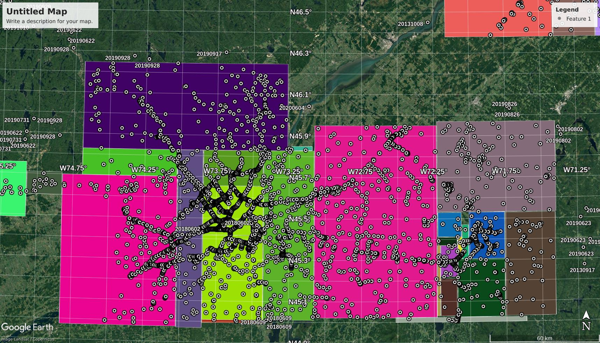

In Toronto cases:

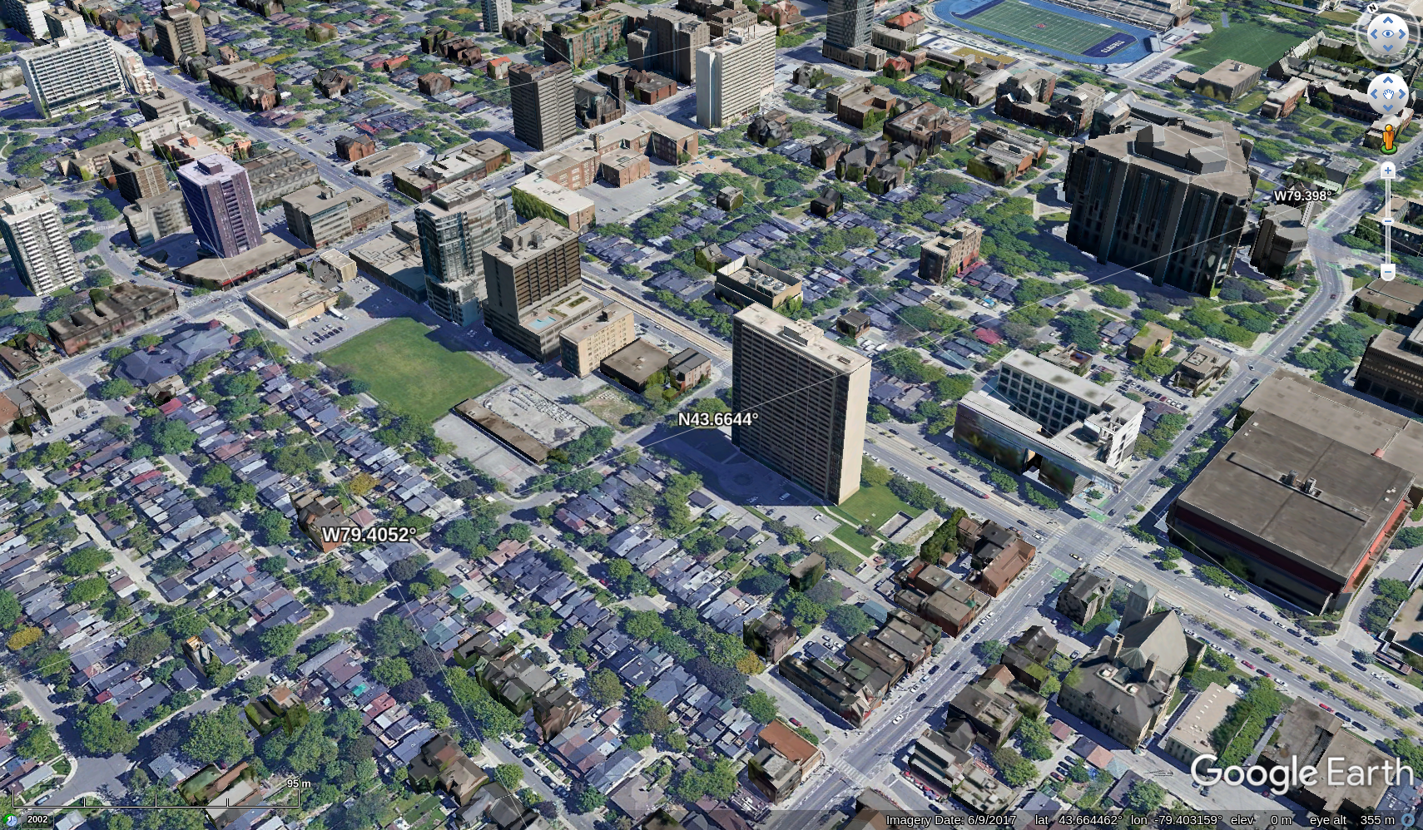&

sun simulator

Alternative way:

Tools to calculate the time ([http://shadowcalculator.eu/#/lat/45.65271285105468/lng/-](http://shadowcalculator.eu/" \l "/lat/45.65271285105468/lng/-74.35121349431152)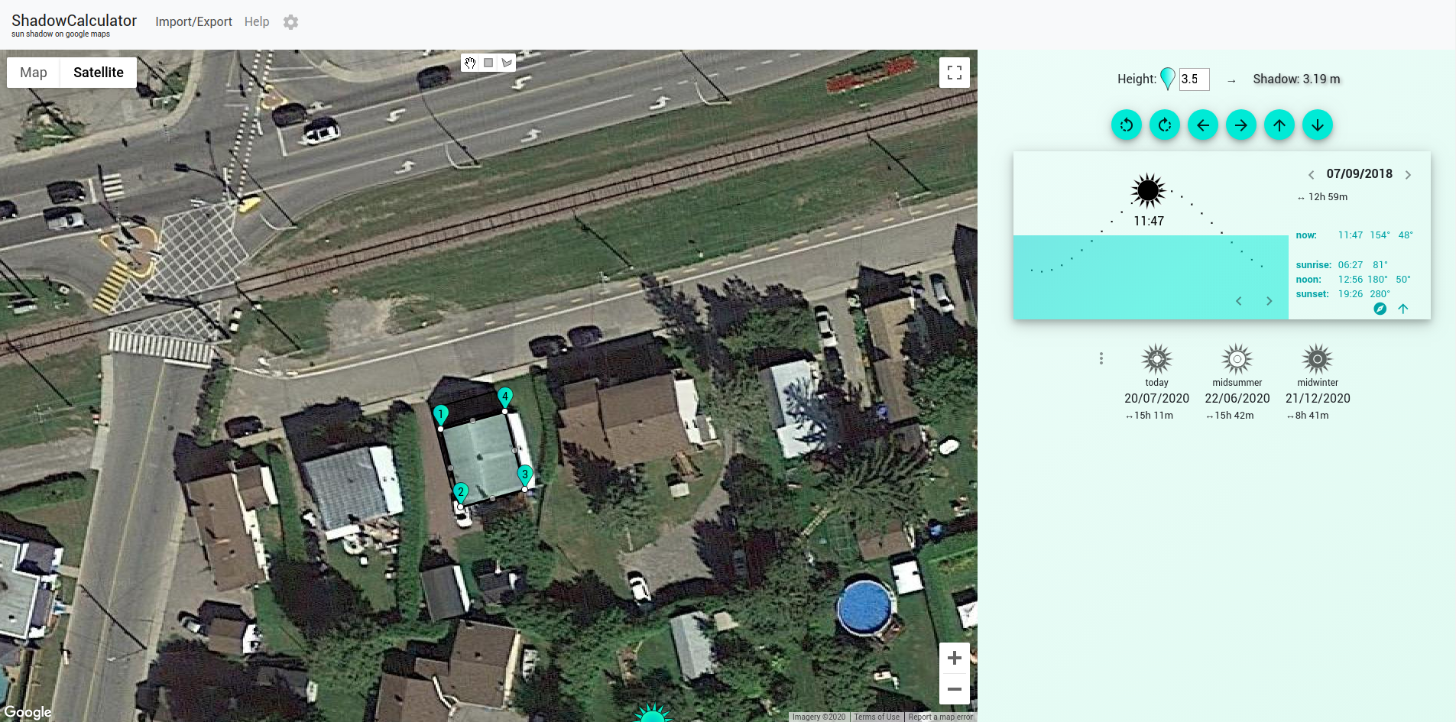74.35121349431152)